
Test 2 Banked Curves, Torque, Equilibrium & Centre of Mass
PHYSICS 3AB TASK 3B
Kingsway Christian College
March 27, 2015

Instructions:
Answer ALL questions.
You may use your formula book and scientific calculator.
Give all numerical answers correct to 3 significant figures.
You are required to show ALL working in order to be given appropriate marks.
A correct answer with no working could receive only ${\frac{1}{5}}^{th}$of the marks allotted.
It is a good idea to draw free body diagrams for questions involving forces.
It is also good to use clear, neat diagrams when appropriate.
Marks________/85 = _______%
Section A: Short answer questions 35 out of 85 marks.
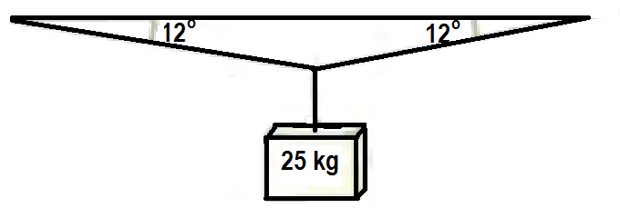
- When a mass of 25 kg is hung from the middle of a fixed straight aluminium wire, the wire sags to make an angle of 12º with the horizontal. Determine the tension in the wire. [3]
By summing up vertical forces,
∑F_{y} = 0 gives
2Tsin12 = 245
∴ T = 245 ÷ (2sin12) = 589.19 ≈ 589 N 
Correct FBD diagram 
T
T
y
x
W = 25 × 9.8
= 245 N
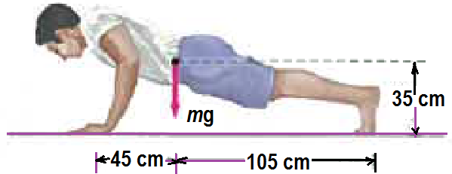
- A man doing push-ups pauses in the position shown. His mass$m=75 kg$. Determine the normal force exerted by the floor
2H
2F
75 × 9.8
= 735 N
  - On each hand [2]
Moments about foot as pivot
2H × 1.5 = 735 × 1.05
∴ H = (735 × 1.05) ÷ 3 = 257 N 
  - On each foot [2]
Summing up vertical forces
2H + 2F = 735
∴ 2F = 735 − 514.5 = 220.5
∴ F = 110 N 
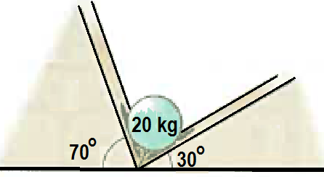
- A 20 kg sphere rests between two smooth planes as shown. Determine the magnitude of the force acting on the sphere exerted by each plane. [4]
Using sine rule $\frac{R_{70}}{sin30}=\frac{196}{sin80}$ $R_{70}=196 \frac{sin30}{sin80}=99.5 N$ ½
and $\frac{R_{30}}{sin70}=\frac{196}{sin80}$ $R_{70}=196 \frac{sin70}{sin80}=187 N$ ½
Correct FBD diagram or force diagram 
30º
70º
80º
R₇₀
R₃₀
196 N
W = 20 × 9.8 = 196 N
R₇₀
R₃₀
30º
70º
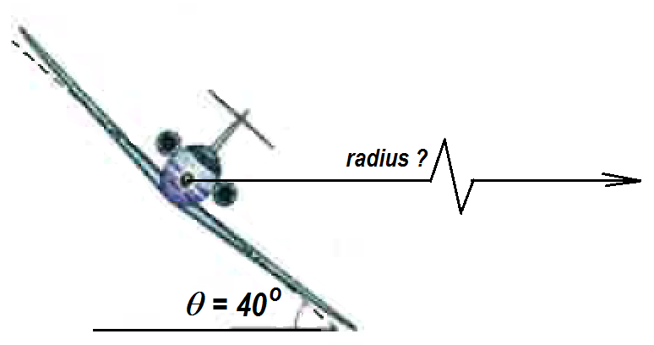
- An airplane is flying in a horizontal circle at a speed of 480 km.h⁻¹.
θ = 40º
W = mg P
Lift force, L P
  - Is it possible for the airplane to fly in a horizontal circle without banking? Explain briefly. No or Yes  [2]
For No. To move in a circular path, a centripetal force is required. Banking enables lift force to produce such a component. For Yes, the tail rudder could be angled to produce that centripetal force or the two engines differently powered to produce it. 
  - Draw the forces acting on the airplane as it flies banked in the horizontal circle. [2]
v = 480 ÷ 3.6 = 133.3 m.s⁻¹
  - Calculate the radius of the horizontal circular fly pathway. [4]
Vertucal forces balance ; Lcos 40 = mg …i
Horizontal net force to centre = centripetal force ; Lsin 40 = mv²/R …ii
ii ÷ i tan40 = v²/gR
∴ R = $\frac{v^{2}}{gtan40}=\frac{133.33^{2}}{9.8 tan 40}=2160 m$
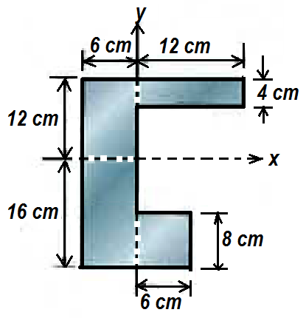
- Calculate the x and y coordinates of the centre of mass of the shape given below. [4]
By taking moments about the origin with x –coordinates of
mass centres as moment arms
264 × $\overline{x}$ = 48 × 6 + 48 × 3 + 168 × (−3)
= − 72
∴ $\overline{x}$ = −72 ÷ 264 = − 0.273 cm 
By taking moments about the origin with y –coordinates of
mass centres as moment arms
264 × $\overline{y}$ = 48 × 10+ 48 × −12 + 168 × (−2)
= − 432
∴ $\overline{y}$ = −432 ÷ 264 = − 1.64 cm 
$$\left(3-12\right) Area 48$$
$$Total Area 264$$
$$\left(-3, -2\right) Area 168$$
$$\left(6, 10\right) Area 48$$
$$\left(\overline{x} , \overline{y}\right)$$
•
•
•
•
- Determine the position of the centre of mass of the system of three particles${ m}_{1}=3 kg, m_{2}=4 kg, and m_{3}=8 kg$. If $m_{3}$ is gradually increased does the centre of mass of the system move closer to${ m}_{3}$, away from${ m}_{3}$ or remain stationary? Briefly explain with appropriate equations. [3]
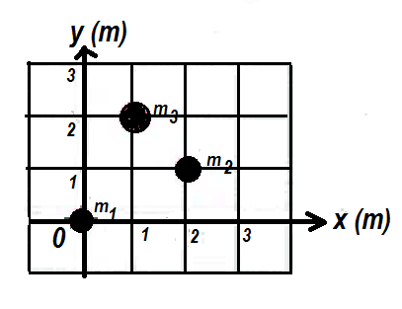
By taking moments about the origin with x –coordinates of
mass centres as moment arms
15 × $\overline{x}$ = 3 × 0 + 4 × 2 + 8 × 1
= 16
∴ $\overline{x}$ = 16 ÷ 15 = 1.07 m 
By taking moments about the origin with y –coordinates of
mass centres as moment arms
15 × $\overline{y}$ = 3 × 0 + 4 × 1 + 8 × 2
= 20
∴ $\overline{y}$ = 20 ÷ 15 = 1.33 m 
The algebraic equations are; (7 + m₃) × $\overline{x}$ = 3 × 0 + 4 × 2 + m₃ ∴ $\overline{x}=\frac{8+m_{3}}{7+m_{3}}=1+ \frac{1}{7+m_{3}}$
(7 + m₃) × $\overline{y}$ = 3 × 0 + 4 × 1 + m₃ × 2 ∴ $\overline{y}=\frac{4+{2m}_{3}}{7+m_{3}}=\frac{14+{2m}_{3}-10}{7+m_{3}}=2- \frac{10}{7+m_{3}}$
$$Total mass 15kg$$
•
$$\left(\overline{x} , \overline{y}\right)$$
As m₃ increases, $\overline{x}$gets closer and closer to 1, the x-coordinate of m₃, and $\overline{y}$gets closer and closer to 2, the y-coordinate of m₃. ∴ as m₃ increases, the combined CM approach the location of m₃. 
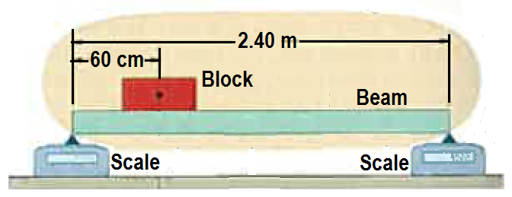
- A uniform beam, of length 2.40 m and mass 12.8 kg is at rest on two scales. A uniform block, with mass 24.6 kg is at rest on the beam, with its centre a distance 60.0 cm from the beam’s left end. What do the scales read? [3]
Moments about the left end
cw = acw
241.08 × 0.6 + 125.44 × 1.2 = R × 2.4
295.176 = 2.4 R
∴ R = 295.176 ÷ 2.4 = 122.99N or 12.55 kg 
By equilibrium of vertical forces
L + R = 241.08 + 125.44 = 366.52 N
∴ L = 366.52 − 122.99 = 243.53 N or 24.85 kg 
∴ Readings are
24.6 × 9.8
= 241.08 N
12.8 × 9.8
= 125.44 N
L
R
 | L | R
Scale (N) | 244 | 123
Scale (kg) | 24.9 | 12.6

- The figure shows a mobile of toy penguins hanging from a ceiling. Each crossbar is horizontal, has negligible mass, and extends three times as far to the right of the wire supporting it as to the left. Penguin 1 has mass 4.80 kg. What are the masses of penguins 2, 3 and 4? [4]
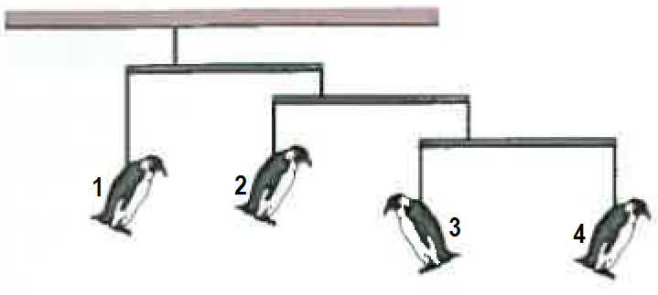
Let the mass of penguin 4 be x;
then that of penguin 3 has to be 3x.
The total mass from Penguins 3 & 4 = 4x.
Then Penguin 2 needs to have a mass of 3 × 4x = 12x.
Total mass of Penguins 2, 3 & 4 = 16x.
Then Penguin 1 needs to have a mass of 3 × 16x = 48x
But this is given as 4.8 kg
∴ 48x = 4.8 ∴ x = 4.8 ÷ 48 = 0.100 kg
∴ Penguin 4 has a mass of x = 0.100 kg or 100 g 
Penguin 3 has a mass of 3x = 0.1 × 3 = 0.300 kg or 300 g 
and Penguin 2 has a mass of 12x = 12 × 0.1 = 1.20 kg or 1200 g 
 for some kind of reasoning like the one above
x
3
1
3
1
3
1
3x
4x
12x
16x
4.8 kg
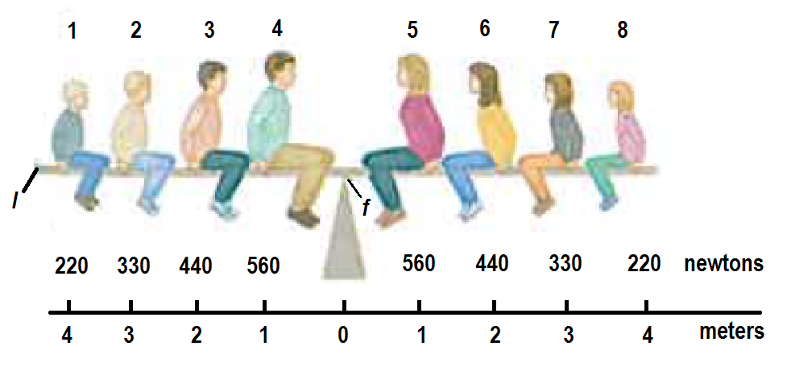
- A Physics Brady Bunch, whose weights in Newtons are indicated is balanced on a seesaw.
  - What is the number of the person who causes the largest torque about the rotation axis at fulcrum f
    - Clockwise [1]
7 
    - Anticlockwise [1]
2 
  - What is the value of the maximum
    - Clockwise torque about f? [1]
330 × 3 = 990 Nm clockwise for person 7 
    - Anticlockwise torque about f? [1]
330 × 3 = 990 Nm anticlockwise for person 2 
  - Write the number of the person and calculate the maximum moment of the person about left end l. [2]
Person 5, τ_{max} = 560 × 5 = 2800 Nm clockwise. 

SECTION B Calculations. Answer all questions. 50 out of 85 marks
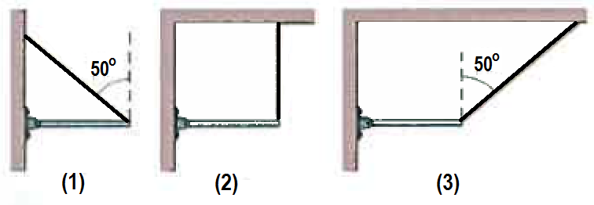
- The figure shows three situations in which the same horizontal rod is supported by a hinge on a wall at one end and a cord at its other end. Rank with some explanation, the situations (greatest first) according to the magnitude of
L sin40
  - The force on the rod from the cord, (1) & (3) equal and greater than (2) [2]
(1) & (3) have smaller but equal moment arm of
Lsin40 about pivot(hinge) producing anticlockwise moment. (2) has moment arm of L and also anticlockwise moment. All 3 have a counteracting equal clockwise moment from the weight of the horizontal rod about hinge. ∴ Tensions in (1) and (3) are equal and greater than that from (2) 
40º
L
L sin40
40º
L
L
  - The vertical force on the rod from the cord, [2]
All vertical components are same and equal as they are all the same perpendicular distance of L from hinge. For (1) & (3) horizontal components have no moment about the hinge as they pass through the hinge. 
  - The vertical force on the rod from the hinge [2]
All vertical forces from hinge on rod are equal to mg − Tcos50 in (1) & (3) and mg − T in (2).
However T in (2) = Tcos50 in (1) & (3) (see also part b) above. 
  - The horizontal force on the rod from the hinge [2]
(1) ; (2) & (3)
H₁ = T₁sin50; H₂ = 0; H₃ = −T₃sin 50 
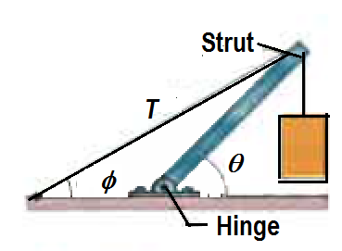
- A concrete block of mass 225 kg hangs from the end of the uniform strut of mass 45.0 kg. For the angles φ = 30.0º and θ = 45.0º find
45º
30º
135º
15º
2205N
441 N
V
H
  - The tension T in the cable [2]
let strut length = L,
then perpendicular distance between line of tension and hinge = Lsin15
Using the hinge as pivot
T × L sin15 = 441 × (L/2)cos45 + 2205 × Lcos45
∴ $T= \frac{1715.09}{sin15}=6625.6 6630 N$
30º
  - The horizontal and vertical components of the force on the strut from the hinge.
[2]
∑F_{H} = 0 gives H = Tcos30 = 6625.6 × cos 30 = 5737.9 N ≈ 5740 N 
∑F_{V} = 0 gives V = 441 + 2205 + Tsin30 = 441 + 2205 + 6625.6sin30 = 5958.8 ≈ 59600 N 
  - The resultant force on the strut from the hinge. [2]
θ
R
5737.9 N

$R = \sqrt{5737.9^{2}+5958.8^{2}}=8272.3 8270 N$  $= \tan^{-1}\left(\frac{5958.8}{5737.9}\right)=46.1^{o}$ 
5958.8 N

- A climber with a weight of 533.8 N is held by a rope connected to her climbing harness. The force of the rope on her has a line of action through her centre of mass. The indicated angles are θ = 40.0º and φ = 30.0º. Her feet are on the verge of sliding on the vertical wall.
  - Draw the free body diagram of the climber. [3]
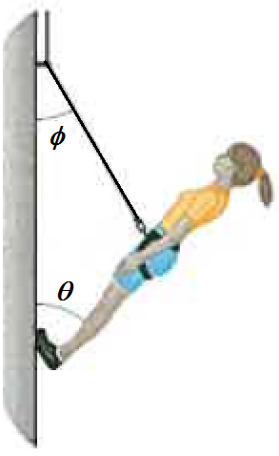
  - What is the tension force of the rope? [3]
There are only 3 forces acting on the climber , two of them, T and W pass through the climber’s CM. Therefore the third R_{F} must also pass through the CM for equilibrium. Assume that the angle between R_{F} and vertical is also θ.
$\frac{T}{sin40}=\frac{533.8}{sin110} T=533.8 \frac{sin40}{sin110}=365 N$ 
 ( Correct force triangle = method)
R_{F}
T
W = 533.8 N 
30º
40º
110º
R_{F}
T
^{W} =
533.8 N
  - What is the resultant force from the wall on her climbing shoes? [3]
$\frac{R_{F}}{sin30}=\frac{533.8}{sin110} T=533.8 \frac{sin30}{sin110}=248 N$  at θ = 30 º down from vertical 
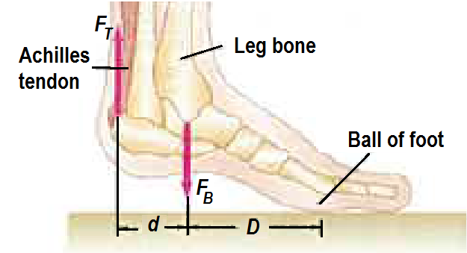
- The Achilles tendon is attached to the rear of the foot as shown. When a person elevates himself just barely off the floor on the “ball of one foot,” estimate the tension ${ F}_{T }$in the Achilles tendon (pulling upward), and the (downward) force${ F}_{B }$exerted by the lower leg bone on the foot. Assume the person has a mass of 72 kg and $D$ is twice as long as$d$. [3]
Since person is on one foot, the whole body weight is the on the foot so for vertical equilibrium, reaction on ball of foot from ground = body weight = 72 × 9.8 = 705.6 N.
Using point of application of F_{B} as pivot
F_{T} × d = 705.6 × D
∴ F_{T} = (705.6 × 2d )÷ d = 1411.2 ≈ 1410 N up 
Summing vertical forces
F_{B} = F_{T} + 705.6 = 1411.2 + 705.6 = 2116.8 ≈ 2120 N down 
705.6 N
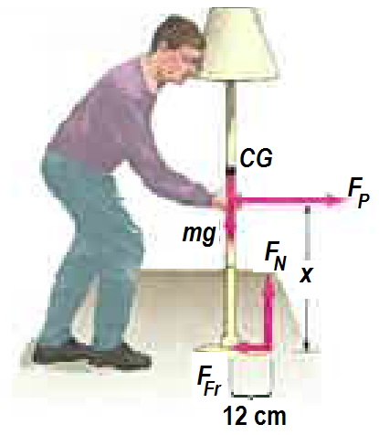
- A person wants to push a lamp (mass 7.2 kg) across the floor, for which the friction force is ${\frac{1}{5}}^{th}$of the normal reaction force. Calculate the maximum height $x$above the floor at which the person can push the lamp so that it slides rather than tips over. [3]
mg = 7.2 × 9.8 = 70.56 N
for vertical equilibrium, F_{N} = mg = 70.56 N 
Using point of application of F_{P} as pivot
F_{Fr} × x = F_{N} × 12
$$x= \frac{F_{N}}{F_{Fr}} 12=\frac{F_{N}}{\frac{1}{5}F_{N}} 12=5 12=60.0cm$$
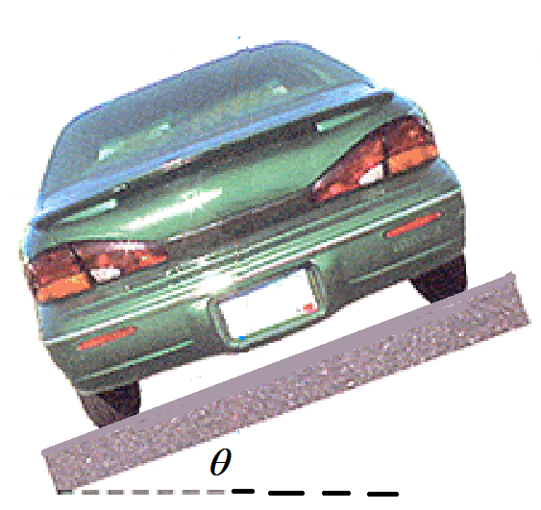
- A banked circular highway curve is designed for traffic moving at 60 km.h⁻¹. The radius of the curve is 200 m?
θ
θ
W = mg 
N 
Ncosθ
Nsinθ
F 
Fcosθ
θ
Fsinθ
200 m radius
  - Calculate the bank angle$.$ [2]
v = 60 ÷ 3.6 = 16.67 m.s⁻¹
Nsinθ = mv²/R
Ncosθ = mg
∴ tanθ = v² ÷ gR = 16.67² ÷ (9.8 × 200) = 0.1417
∴ θ = tan⁻¹(0.1417) = 8.07º 
  - The 1600 kg car is travelling at 40 km.h⁻¹ on this rainy day.
    - Draw the forces acting on the car for this situation. [3]
    - Write the equations of motion for the vertical and horizontal forces. [2]
Here v = 40 ÷ 3.6 = 11.11 m.s⁻¹
Vertical forces: Fsinθ + Ncosθ = mg or Fsin8.07 + Ncos8.07 = 1600 × 9.8 
Horizontal forces: Nsinθ − Fcosθ = mv²/R or Nsin8.07 − Fcos8.07 = 1600 × 11.11²÷ 200 
  - The car speeds up to 80 km.h⁻¹. Calculate the sideways frictional force and normal reaction force on the car for this situation. [4]
v = 80 ÷ 3.6 = 22.22 m.s⁻¹
Vertical forces. Ncos8.07 − Fsin8.07 = 15680
divide through by sin8.07 to get
7.053 N − F = 111694.5653 …i
Horizontal forces:
Nsin8.07 + Fcos8.07 = 1600 × 22.22² ÷ 200
divide through by cos 8.07 to get
0.1418 N + F = 3990.130357 …ii
i + ii
7.1948 N = 115684.6957
N = 115684.6957 ÷ 7.1948 = 16078.9 ≈ 16100 N perpendicular up 
F = 3990.13 − 0.1418 16078.9 = 1710.3 ≈ 1710 N downslope 
θ
N
Ncosθ
Nsinθ
θ
F
W = mg = 15680 N
Fsinθ
Fcosθ
θ
- Consider a ladder with a painter climbing up it. If the mass of the ladder is 15.0 kg, the mass of the painter is 65.0 kg and the ladder begins to slip at its base when her feet are 70% of the way up the length of the ladder. Assume a smooth wall. Calculate
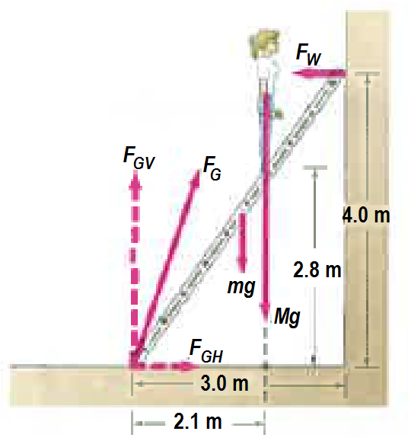
  - The wall reaction force [3]
Taking moments about foot of ladder
F_{W} × 4 = 147 × 1.5 + 637 × 2.1 = 1558.2
∴ F_{W} = 1558.2 ÷ 4 = 389.55 ≈ 390 N 
637 N
147 N
  - The ground reaction force. [4]
∑F_{H} = 0 ∴ F_{GH} = F_{W} = 389.55 N ½
∑F_{V} = 0 ∴ F_{GV} = mg + Mg = 147 + 637 = 784 N ½
θ
R
389.55 N
784 N
$R =\sqrt{{389.55}^{2}+{784}^{2}}=875.45 875 N$  $= \tan^{-1}\left(\frac{784}{389.55}\right)=63.6^{o}$ 
Ground reaction force = 875 N at 63.6º up from horizontal 

  - Describe some practical solutions on how to make the ladder more stable, based on your Physics knowledge of stability and equilibrium. [3]
1) Rest foot of ladder against a fixed support so it can’t slide
2) make base of ladder heavier by using denser material or adding weights to bottom part of ladder. This will reduce the CG/CM.
3) Widen the base area of ladder by resting the foot in very wide plate area structures to increase base area.
4) Hook base of ladder to some fixed point on wall by a strong cord to prevent sliding.
Note that this question is looking at stability and equilibrium so you have to talk about things to
a) Lower the centre of mass/centre of gravity
b) Increase the base area so it takes time for the line of action of the weight force to fall outside the base area leading to tipping over or instability.
END OF TASK 3b (Test 1b)

